**Load Balancing in AWS**

* Path Based Layer 7 Load Balancing  
  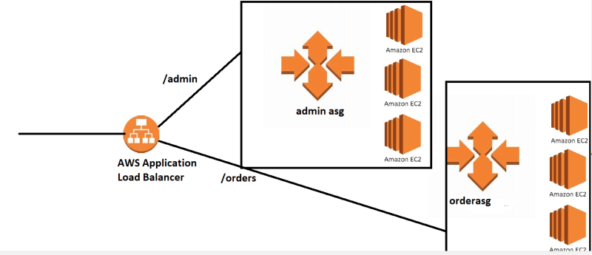
* Multi Region (Active – Active) or (Active – Passive)  
  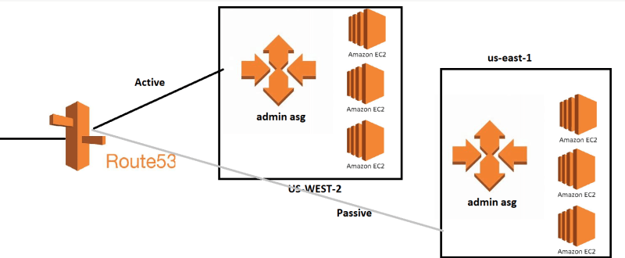

**Lab Setup: Creating AMIs**

* Create two amis
  + adminami:
    - create a ubuntu ami based ec2 instance
    - Execute the following commands  
      sudo apt update  
      sudo apt install apache2 -y  
      echo "<h1> This is admin page </h1>" > index.html  
      sudo cp index.html /var/www/html/index.html
    - Create an AMI
  + orderami:
    - create a ubuntu ami based ec2 instance
    - Execute the following commands  
      sudo apt update  
      sudo apt install apache2 -y  
      echo "<h1> This is order page </h1>" > index.html  
      sudo cp index.html /var/www/html/index.html
    - Create an AMI
* Once the AMIs are ready lets create admin launch template and order launch template  
  